# Python Worksheet :: loops

Using the loops **for**, **while** complete the following tasks:

1. Output numbers from 1 to 10

2. Output numbers 0 to 10

3. Output numbers 10 to 1

4. Output square numbers up to 10

5. User enters a number, output numbers 1 to that number

6.

|  |  |
| --- | --- |
|  |  |

Google “Python random randint” to make sure you know how it works and the possible random numbers it will return.

Output dice rolls and the running total. Stop when the total is larger than 27. E.g:

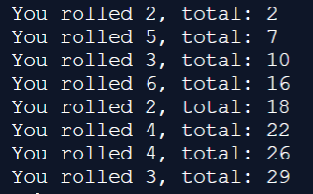

7. Sum numbers up to user entered value. E.g. I enter 5, you display 1+2+3+4+5 = 15

8. Output the times table (user selected):

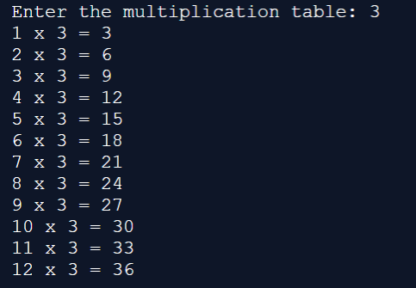

9.

Make sure you understand the following code:

|  |  |
| --- | --- |
|  |  |

Now, output the following:

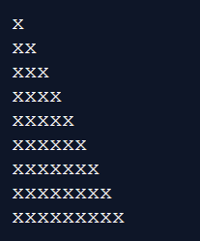

10. Output the following:

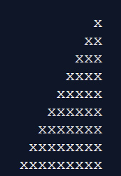

11. Output the following:

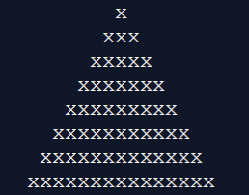

12. Output the following:

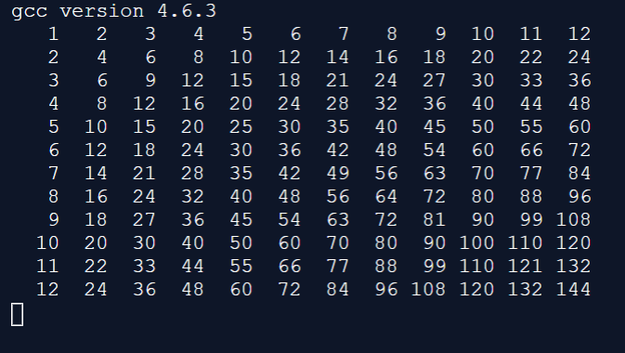

13.

You are to create a program that allows a user to type in 3 whole numbers, and then display appropriate messages with the three numbers in ascending order and the mean average of the three numbers.

This solution **must** make use of **nested selection and compound statements**. You are **not to use** any pre-defined max() or min() or sorting functions that Python has.